Introduction to the Sacrament

Prayer of Thanksgiving and Pouring of Water

Presentation of the Candidate
On behalf of Trinity United Church, I present the following persons for initiation into the body of Christ through the Sacrament of Baptism:
Bruin Jare Baumgartner
Morris James Gall

Statement of Faith
We are not alone, we live in God’s world.
We believe in God:
who has created and is creating,
who has come in Jesus, the Word made flesh,
to reconcile and make new,
who works in us and others by the Spirit.
We trust in God.
We are called to be the Church:
to celebrate God’s presence,
to live with respect in Creation,
to love and serve others,
to seek justice and resist evil,
to proclaim Jesus, crucified and risen,
our judge and our hope.
In life, in death, in life beyond death, God is with us.
We are not alone.
Thanks be to God!

Questions of the Parents

Questions of the Candidate (Bruin)
Questions of the Godparents

Questions of the Candidate (Morris)

Question of the Congregation:
We receive these persons in Christ’s name, as we ourselves have been received. Will you support them with constant love, wholesome example, Christian teaching and faithful prayer? If so, please answer “We will, God being our helper.”

Congregation: We will, God being our helper.

Act of Baptism

Declaration and Congregational Welcome:
Into the household of faith, we welcome you with joy and thanksgiving.
We are members of the Body of Christ.
We are inheritors of God’s promise.
In the name of Christ, we welcome you.

Hymn: VU #452 “You Have Put on Christ”
You have put on Christ,
in Christ you have been baptized.
Hallelujah, hallelujah!

Presentation of the Baptismal Candle

Presentation of the Baptismal Certificate

Presentation of the Bible

Blessing: VU #454 “May God Who Creates You”
May God who creates you give you light,
may God who sustains you make you wise,
may God who protects you give you joy,
may God who surrounds you give you peace.

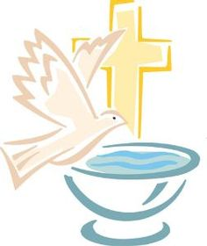
SACRAMENT
OF
HOLY BAPTISM

