Introduction to the Sacrament

Prayer of Thanksgiving and Pouring of Water

Presentation of the Candidate
On behalf of Trinity United Church, I present Catherine Isobel Sinclair for initiation into the body of Christ through the Sacrament of Baptism.

Questions of the Parents:
Do you present yourself, earnestly desiring that by Holy Baptism you be made a member of the church of Christ?

Do you believe in God, who has created and is creating, who has come in Jesus, the Word made flesh, to reconcile and make new, and who works in us and others by the Spirit?

Will you follow in the way of Jesus Christ, resisting oppression and evil, seeking justice, and witnessing to God’s love for all creation?

Will you join with your brothers, sisters and siblings in this community of faith as you are able to celebrate God’s presence, live with respect in creation and love and serve others?

Will you continue to learn in the knowledge and love of God of the truths and the duties of the Christian faith?

Question of the Congregation:
We receive Cath in Christ’s name, as we ourselves have been received. Will you support her with constant love, wholesome example, Christian teaching and faithful prayer?

We will, God being our helper.

Act of Baptism

Declaration and Congregational Welcome:
Friends, this is the newest member of our church family. Cath, these are your brothers and sisters and aunts and uncles in the faith. As we have pledged our support to Cath, let us also now join together in words of welcome and signs of celebration saying together the words printed in your bulletin.

Into the household of faith, we welcome you with joy and thanksgiving.
We are members of the Body of Christ.
We are inheritors of God’s promise.
In the name of Christ, we welcome you.

Hymn: VU #452 “You Have Put on Christ”

Presentation of the Baptismal Candle

Presentation of the Baptismal Certificate

Presentation of the Bible

Sung Blessing: VU #454 “May God Who Creates You”

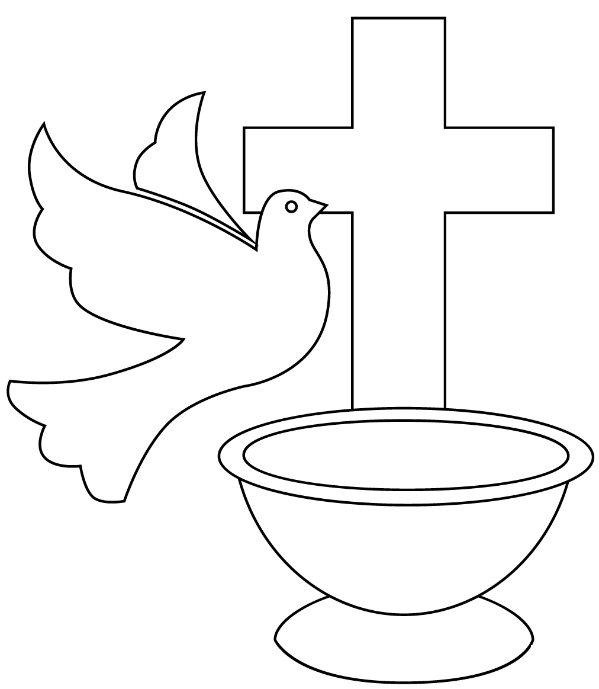
SACRAMENT
OF
HOLY BAPTISM

